Mini Dry Bath Incubator—MiniBox-C
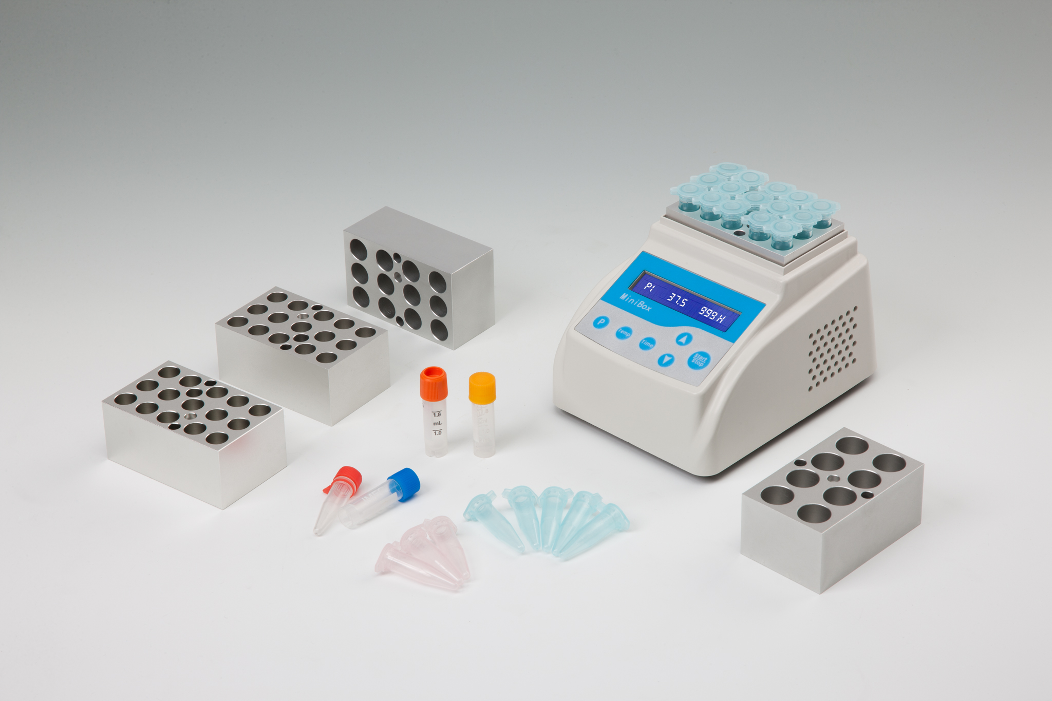
Description:
Minibox-C is a microprocessor-controlled product. It is widely used in preservation and reactions of sample, DNA amplification and initial denaturation of electrophoresis and so forth. It fits almost anywhere and can even be used in cars, boats or wherever a 12 volt power source is available.

Features:
- Energy-efficient design.
- Applicable to 12V power adapter.
- Accurate to ± 0.3℃.
- Process of experiment is visible.
- Electronic calibration. User can reset to any local standard.
- Power supply provided is UL, CSA and CE approved.
- Custom blocks made to fit any sample holder.

Parameters:
Type  Parameters | Minibox-C
Temperature range | 0℃～100℃
Temp. control range | RT.-15℃～100℃
Timing range | 1sec～5999sec/∞  1min～5999min/∞
Temp. accuracy | ≤±0.3℃*
Display accuracy | 0.1℃
Temp. uniformity | ≤±0.3℃*
Heating time | ≤20min(from 25℃ to 100℃)*
Cooling time 1 | ≤20min(from 100℃ to 25℃)*
Cooling time 2 | ≤25min(from RT. to RT.-15℃)*
AUTO-4℃ | Yes*
Multi points running | Yes(Max. 5points)
Multi cycle | Yes(Max. 99times)
Auto heating | Yes
Auto running | Yes
Auto resume to run | Yes
Input power | DC12V
Max. power | 60W
Dimension(W×D×H) | 145×113×140mm
Net weight | 1.0kg
*Test condition：RT.25℃±2℃, use 15x1.5ml block, use mercurial thermometer, accuracy
is ±0.1℃

Type Description
MiniBoxA 15×2.0ml
MiniBoxB 15×1.5ml
MiniBoxC 24×0.5ml
MiniBoxD 32×0.2ml (for 0.2ml PCR 8-tube strip)
MiniBoxF 32×0.2ml (for 0.2ml Elisa 8-well strip)

